**PHOTOVOLTAIC SYSTEM WITH DC TO DC BOOST CONVERTER (Using MPPT) AND THREE PHASE DC TO AC INVERTER**

*Khushboo Chaurasiya, Manvendra Singh Holkar, Mahima Chahar*

*Indian Institute of Technology Varanasi (BHU)*

E-mail: [khushboo.chaurasiya.eee21@itbhu.ac.in](mailto:khushboo.chaurasiya.eee21@itbhu.ac.in), [manvendra.sholkar.eee21@itbhu.ac.in](mailto:manvendra.sholkar.eee21@itbhu.ac.in), [mahima.chahar.eee21@itbhu.ac.in](mailto:mahima.chahar.eee21@itbhu.ac.in)

***Abstract*—***The main purpose of this paper is to introduce an approach to design DC to DC boost converter(Using MPPT) and Three phase DC TO AC inverter for photovoltaic system. The boost converter is designed to step up a fluctuating solar panel voltage to a higher constant DC voltage. From constant dc voltage we then design a 120degree notation dc to ac inverter (using 6 IGBT) by providing pwm gate pulses to 6 IGBT with 120 degree phase difference. Simulations were performed to describe the proposed design*.

# I. INTRODUCTION

Nowadays, power generation using solar power had increased dramatically because it is pollution free as compare to power generation using fossil fuel. Besides, it needs low maintenance and no noise and wear due to the absence of moving parts which make solar power attractive to the people. Solar energy can be converted into electrical energy through the use of photovoltaic (PV) cells, also known as solar cells. These cells are made from semiconductor materials, such as silicon, and are designed to absorb sunlight and convert it into electricity. As the sun irradiation and temperature changes, output voltage changing as well. Since the voltage produced is fluctuating, a lot of electronic equipments are unable to be directly connected. Therefore, a DC-DC boost converter with constant output voltage is needed. The boost converter will step up the solar panel voltage to the suitable voltage required by electronic equipments. For AC electrical equipments, the system requires an additional AC-DC inverter which converts the constant DC voltage to AC voltage. This system is called dual power processing stage system. Figure 1 shows a grid connected PV application system using dual power processing system.

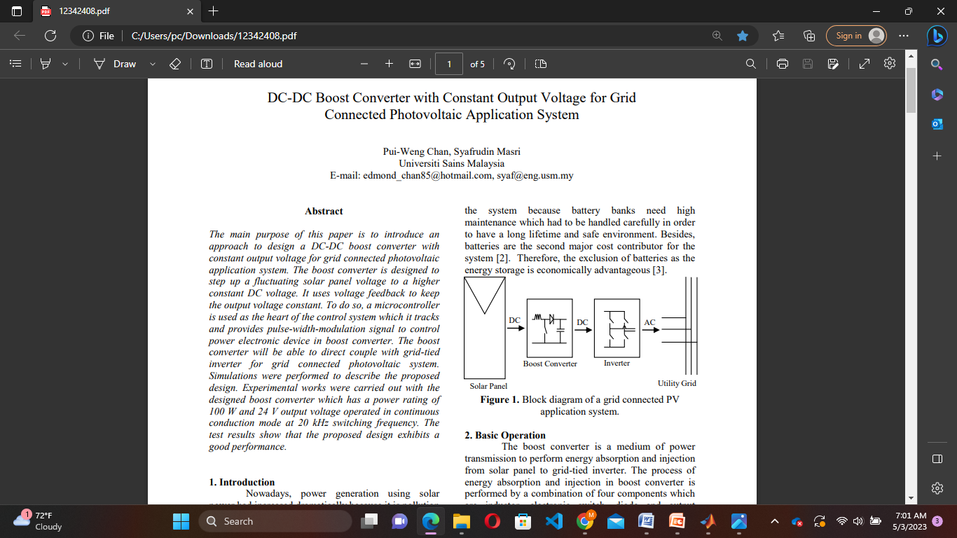

Fig. 1. Block diagram of a grid connected PV application system.

# II. BOOST CONVERTER

A boost converter is a type of DC-DC converter that steps up the voltage of a DC input to a higher DC output voltage. It is called a "boost" converter because it boosts the input voltage to a higher level. Boost converters are commonly used in applications where a higher voltage is needed than the available input voltage. r. The connection of a boost converter is shown in Figure 2. The process of energy absorption and injection will constitute a switching cycle. In other word, the average output voltage is controlled by the switching on and off time duration. The switching cycle is controlled by the mppt algorithm(here we are using perturb and observe algorithm). The switching duty cycle, D is defined as the ratio of the on duration to the switching time period.

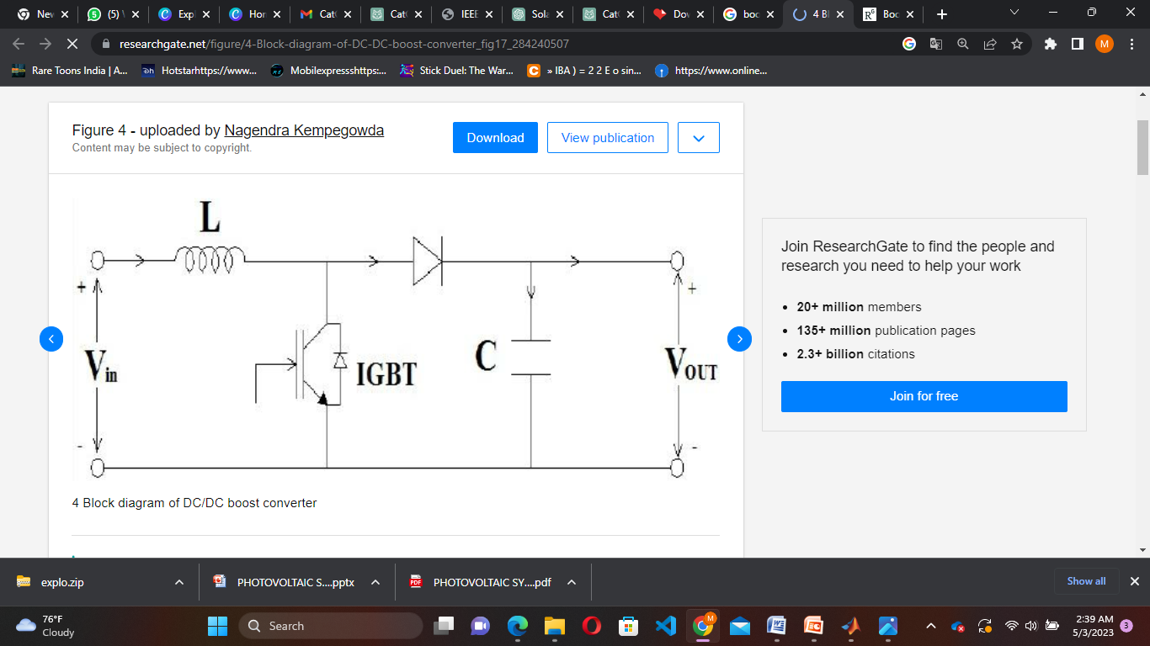

Fig. 2. Schematic of boost converter.

Working of boost converter is divided into two modes.

2.1. Mode 1: Switch is On, Diode is Off

Mode 1 begins when the switch SW is turned on at t = 0. The input current which rises flows through inductor L and switch SW. During this mode, energy is stored in the inductor and load is supplied by capacitor current.

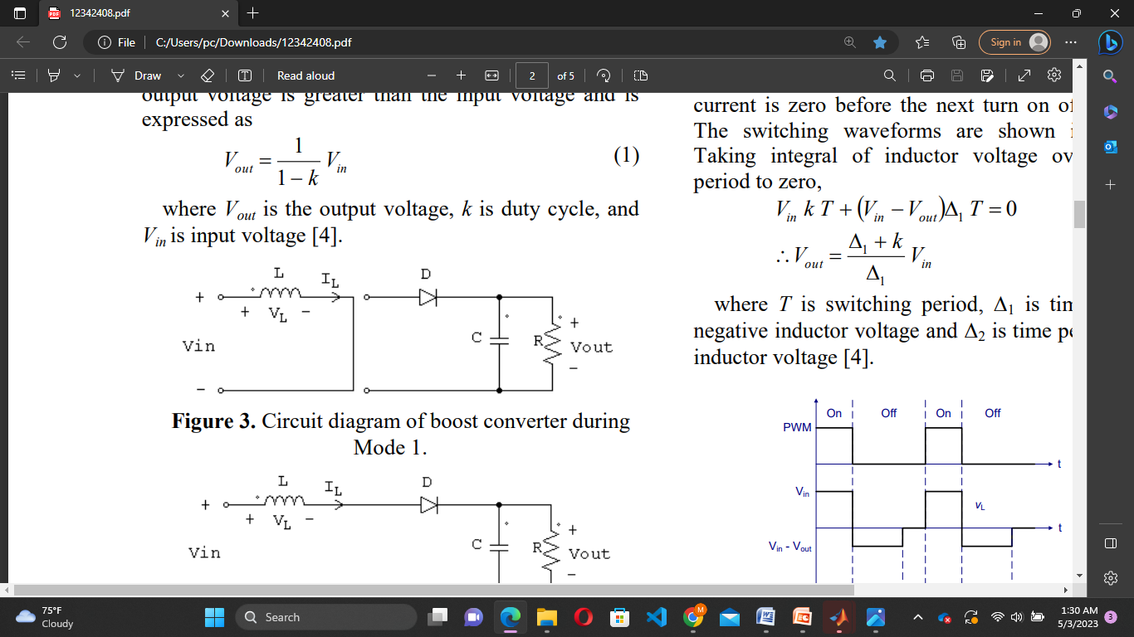

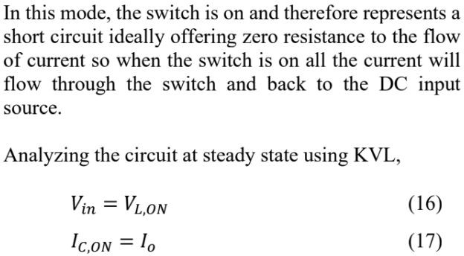



2.2. Mode 1: Switch is On, Diode is Off

Mode 2 begins when the switch is turned off at t = DT. The current that was flowing through the switch would now flow through inductor L, diode D, output capacitor C, and load R. The inductor current falls until the switch is turned on again in the next cycle. During this time, energy stored in the inductor is transferred to the load together with the input voltage. Therefore, the output voltage is greater than the input voltage.

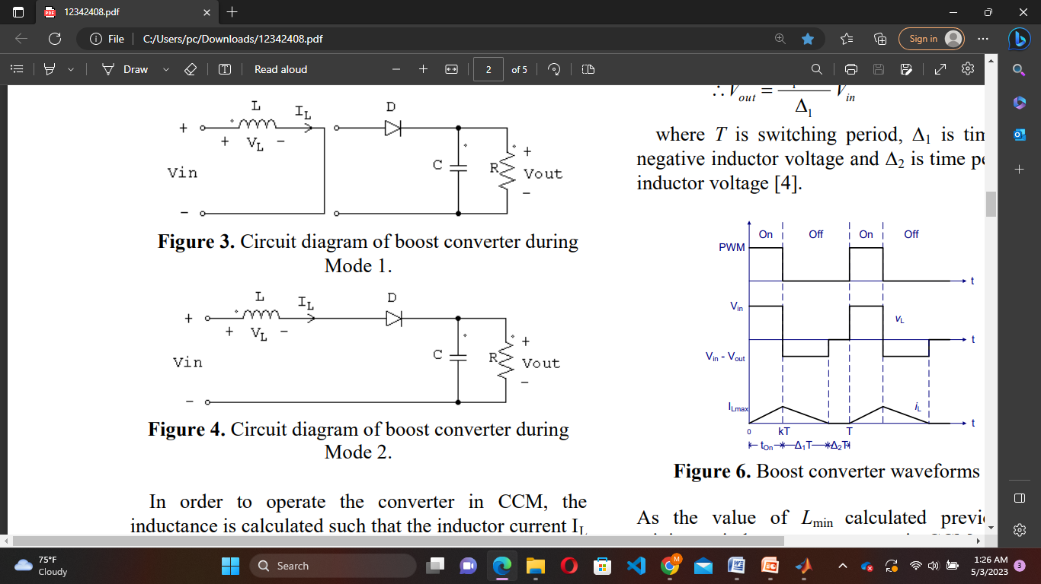

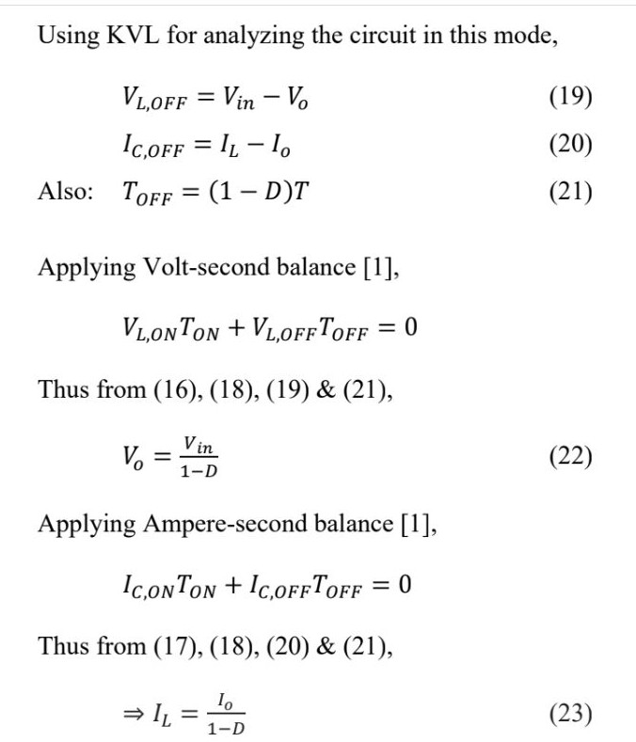

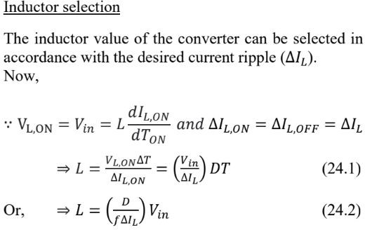

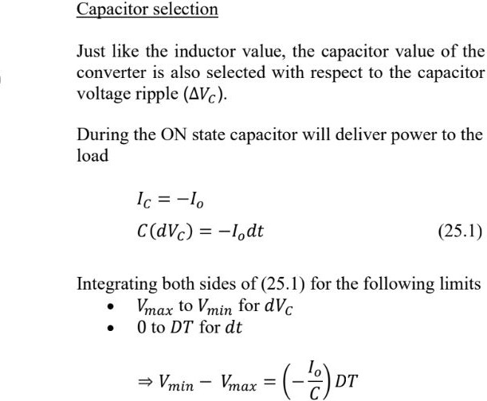

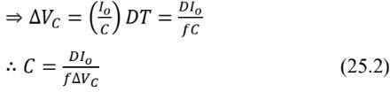

III. MPPT(Maximum Power Point Tracking) :

MPPT or Maximum Power Point Tracking is algorithm that included in charge controllers used for extracting maximum available power from PV module under certain conditions. The voltage at which PV module can produce maximum power is called „maximum power point‟ (or peak power voltage). Maximum power varies with solar radiation, ambient temperature and solar cell temperature.Using the fact that input power is equal to output power , we can get:

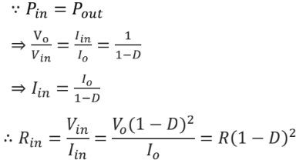

Hence by the maximum power transfer theorem, maximum power will extracts from the solar panel when transferred load resistance is equal to the internal resistance. This condition is achieved by this proposed maximum power point tracking (MPPT) algorithm.Where,The proposed control strategy will set the duty cycle of converter so as to match transferred load resistance with internal resistance of solar panel

3.1. Perturbation and Observation Method:

When we observe the PV curve , We ﬁnd out that :In the given curve, D = 1.0 at the origin, and D = 0.0 at thus, the value of D decreases as we move from left to right in the curve. Now, we can divide the power curve into 2 parts for analysis. The part to the left of the maximum power point, and the part to the right of it. In the left part, the power output increases as we increase the voltage, or in other words, the power output increases with a decrease in the value of D. Contrast to this, in the right part of the curve, the increasing voltage (or the decreasing D) leads to a decrease in the power output.From this Observation P and O method come.

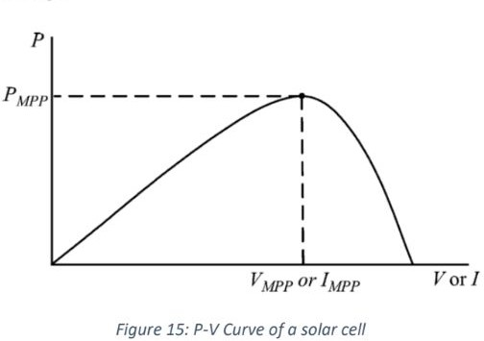

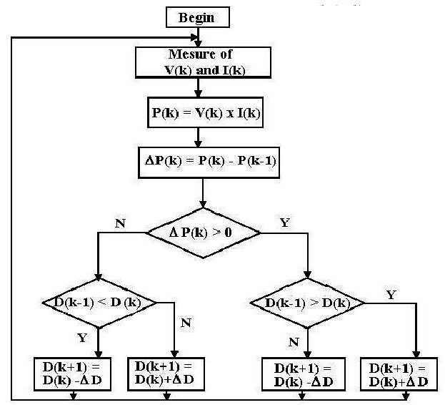

Fig. 3 Flow Chart of Perturb and Observe Method Algorithem.

instructions assume Microsoft *Word*. Some versions may have alternate ways to access the same functionalities noted here). Then, type over sections of the template or cut and paste from another document and use markup styles. The pull-down style menu is in the Formatting Toolbar at the top of your *Word* window (e.g., the style at this point in the document is “Text”). Highlight a section that you want to designate with a certain style, and then select the appropriate name on the style menu. The style will adjust your fonts and line spacing. Do not change the font sizes or line spacing to squeeze more text into a limited number of pages.Use *italics* for emphasis; do not underline.

IEEE will do the final formatting of your article. If your article is intended for a conference, please observe the conference page limits.

This is intended as an authoring template, not a final production template. It is not intended to match the final published format. Differences in final formatting are likely in the final IEEE files. Page count in the template is an estimate. Do not adjust line and character spacing to fit your paper to a specific length.

## IV. Three phase DC to AC inverter

A three-phase DC to AC inverter is a device that converts DC (Direct Current) power into AC (Alternating Current) power with three-phase output. The inverter is used in various applications, including renewable energy systems, motor control, uninterruptible power supply, and many others.

There are different types of three-phase DC to AC inverters, including pulse width modulation (PWM) inverters, sinusoidal pulse width modulation (SPWM) inverters, and multilevel inverters. PWM inverters are the most common type of inverter used in industrial applications due to their simplicity and cost-effectiveness. SPWM inverters are preferred for applications requiring a high-quality output waveform, such as motor control.

## 4.1. SINUSOIDAL PULSE WIDTH MODULATION (SPWM**)**

The gating signals are generated by comparing a sinusoidal reference wave with a triangular carrier wave of frequency Fr and Fc respectively. When the sinusoidal wave has a higher magnitude, output is high otherwise it is low. The comparator output is processed in a trigger pulse generator in such a way that the output voltage wave has a pulse width in agreement with comparator pulse width.

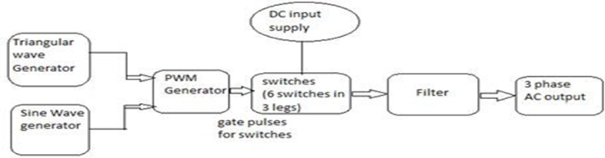

## 4.2.. SWITCHING TECHNIQUES

To provide the gate signals to the switches in an inverter, two types of switching schemes are used-Unipolar and Bipolar voltage switching. If the triangular carrier wave is either in the positive or negative polarity range of changes, the resulting SPWM wave lies only in the polarRange, this type of switching is called unipolar control mode. Whereas if the triangular carrier wave lies in continuous range between both positive and negative polarity, the SPWM wave lies between positive and negative changes, this switching is known as bipolar control.

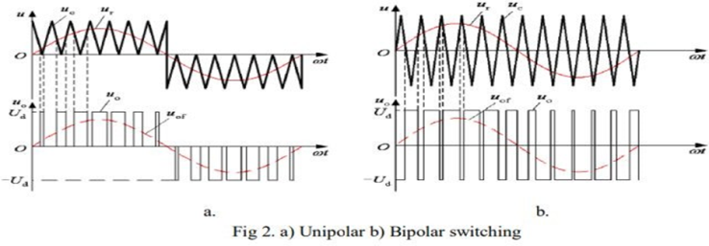

## 4.3. SWITCHING TECHNIQUES IN THREE PHASE INVERTER

Here, triangular carrier wave is compared with three reference sinusoidal waves (U,V,W) which are displaced by 120 degrees.

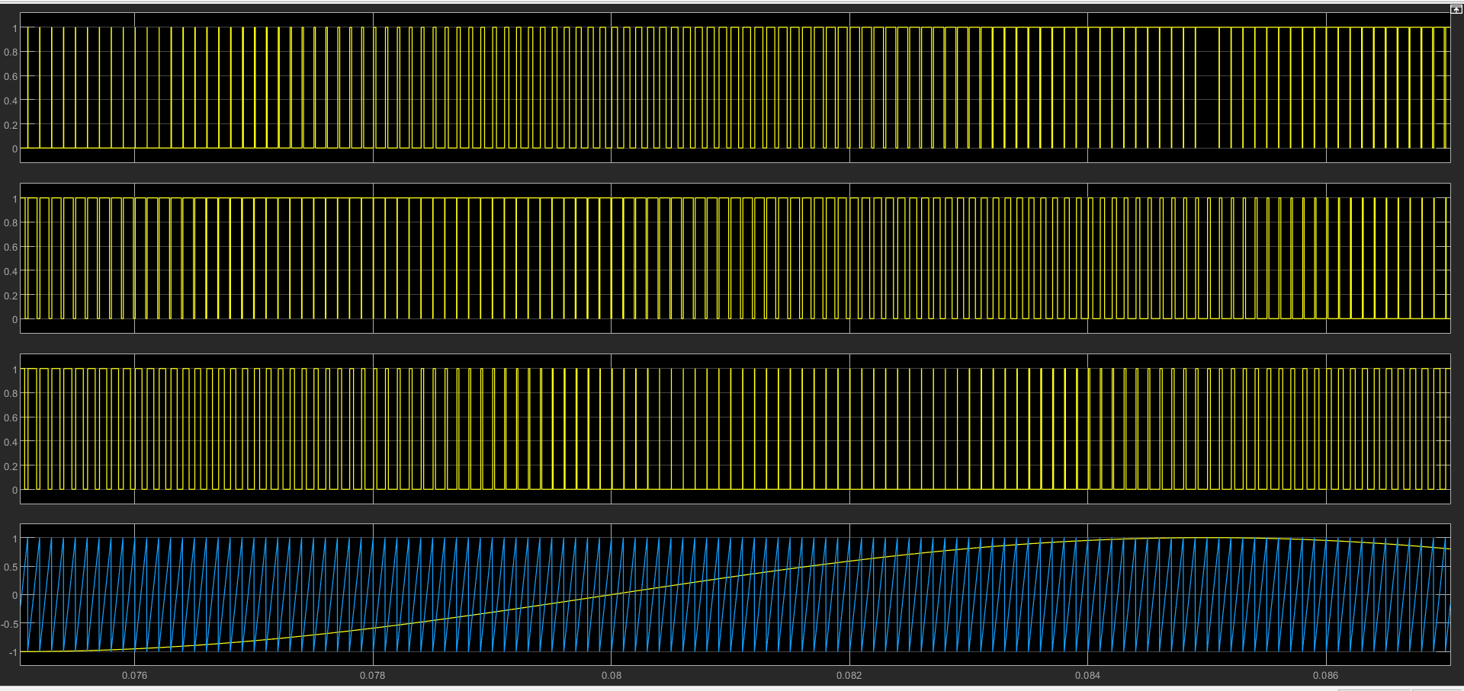

## V. Simulation

## 5.1. Simulink Model for Solar PV array with DC to DC Boost converter and MPPT.

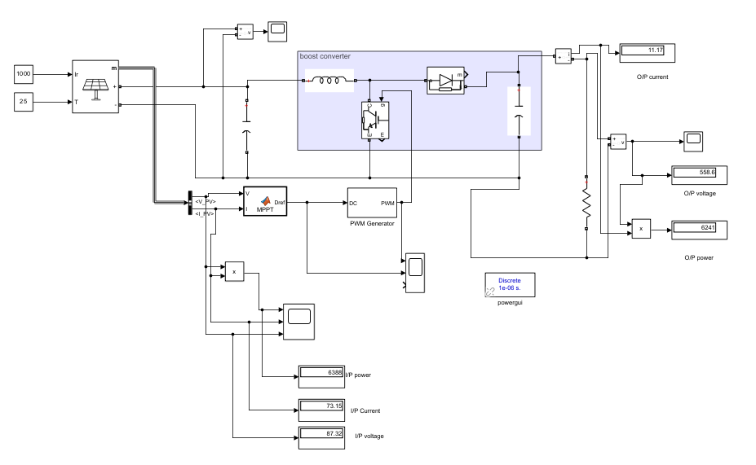

## 5.2. Simulink Model for SPWM Inverter with LC ﬁlter

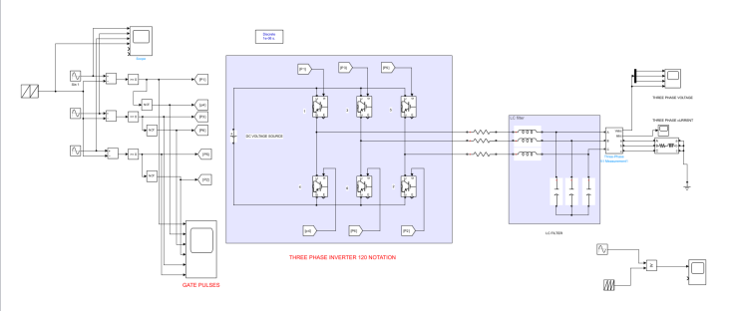

## VI. Simulation Results

## 6.1. I-V Characteristic Curve and P-V Characteristic Curve

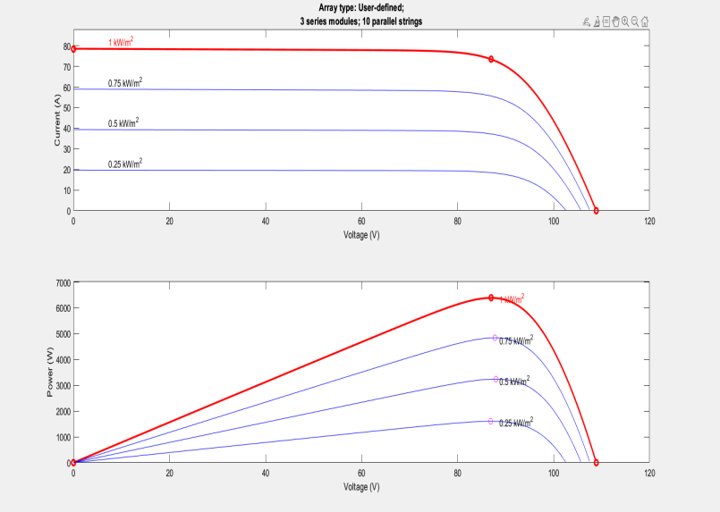

## 6.2. Phase to Ground Output voltage of inverter vs time(Before LC Filter)

## 

## 6.3. 3 Phase Output Current vs time(Before LC Filter)

## 

## 6.4. Phase to Ground voltage vs time(After LC Filter)

## 

## 6.5. 3 Phase Output Current vs time(After LC Filter)

## 

## VII. Conclusion

In conclusion, a photovoltaic system with a DC to DC boost converter (using MPPT) and a three-phase DC to AC inverter is an efficient and effective way to convert solar energy into usable electricity. The DC to DC boost converter with MPPT maximizes the energy harvested from the solar panels and regulates the voltage to match the requirements of the inverter. The three-phase DC to AC inverter converts the DC power into three-phase AC power with a high level of efficiency and quality waveform.

This system is suitable for various applications, including residential, commercial, and industrial, and it can help reduce dependence on grid electricity and lower electricity bills. The system's performance can be further improved by using high-quality components and optimizing the system design to match the specific requirements of the application. Overall, this system is a reliable and sustainable solution for converting solar energy into usable electricity.